**Final Project Report**

**Name : NITIN SINGH RAWAT**

**Student ID: M20W0175**

**Following are the Requirements of the Project.**

**(1)** Having a Database.

**(2)** Having the Entities and the relationships.

**(3)** Spring Security settings.

**(4)** Rest controller having (CRUD).

**Relational Schema**

|  |
| --- |
| **Book** |
| Price |
| ID |
| Created |

|  |
| --- |
| **Lecture** |
| ID |
| Subject Name |
| Period |

|  |
| --- |
| **Student** |
| ID |
| Email |
| Password |

The above is the relational schema which is realized as:

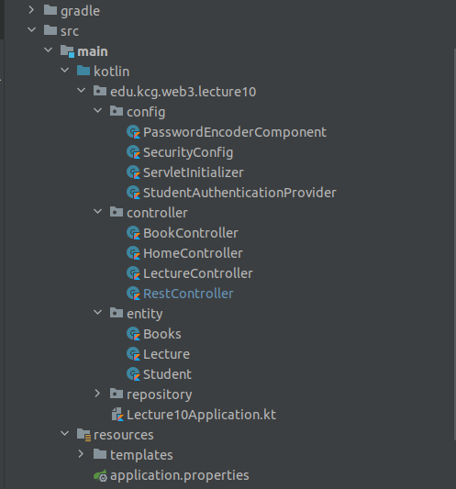

Here the entity part is created which is holding the code for creating the tables and their corresponding columns and their relationships.

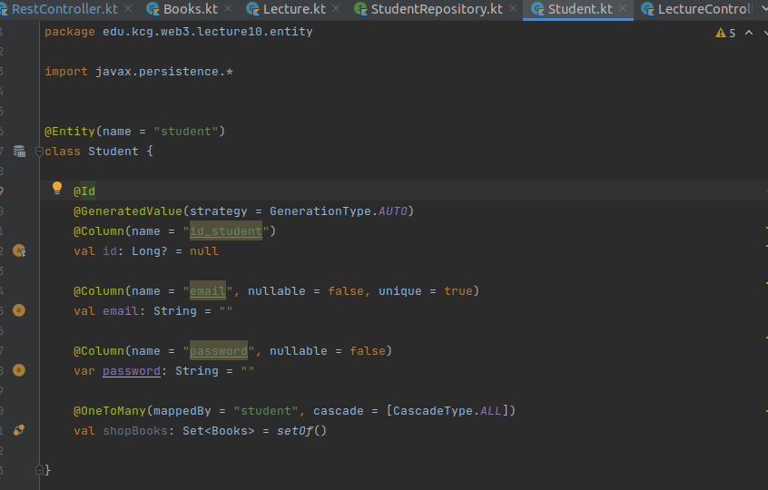**Student Entity:**

**Lecture Entity:**

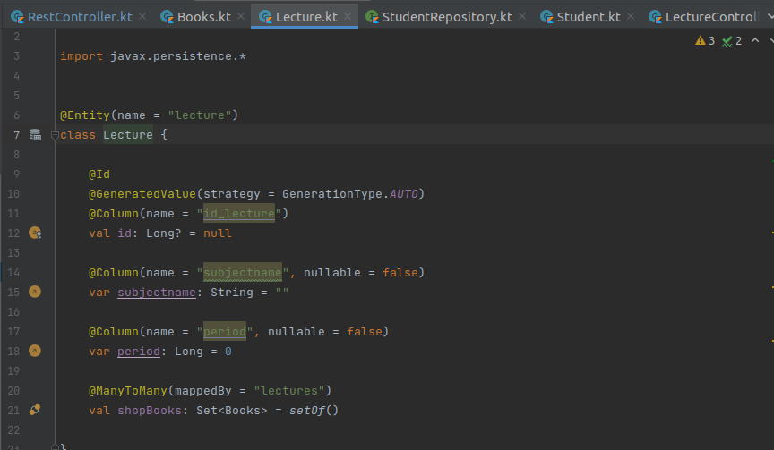

**Books Entity:**

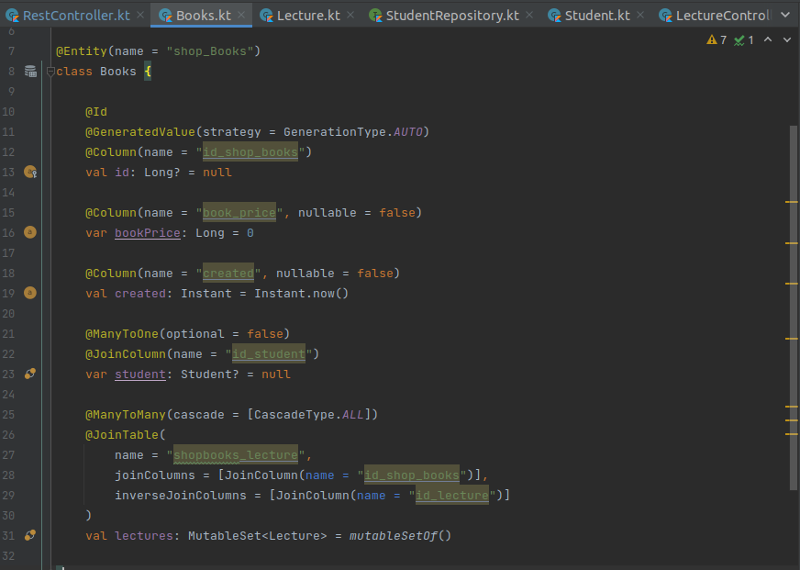

**Here is the Output Looks:**

**Home Page**

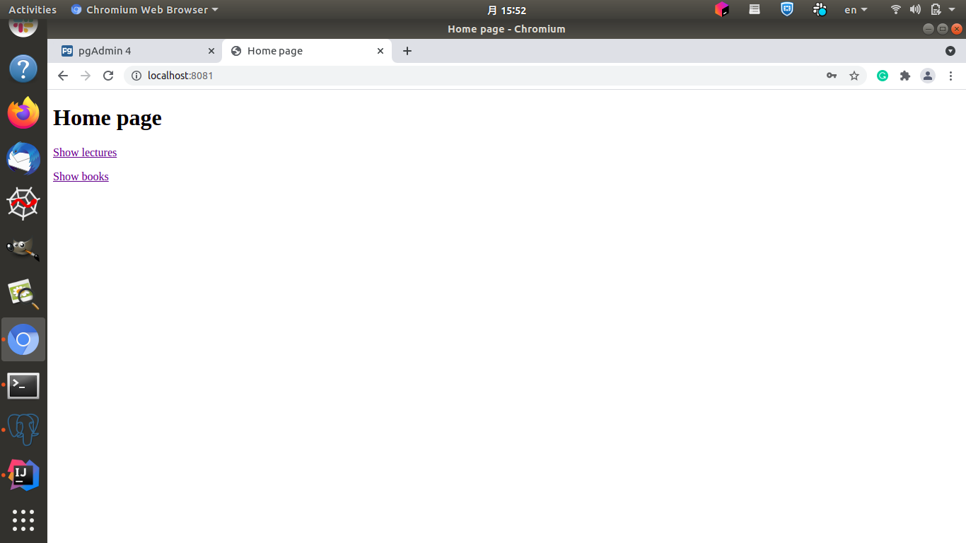

**Lecture Page**

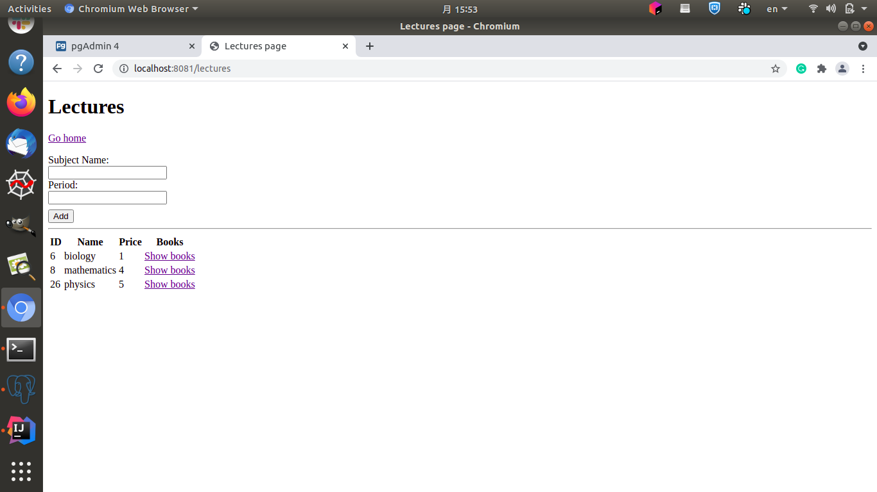

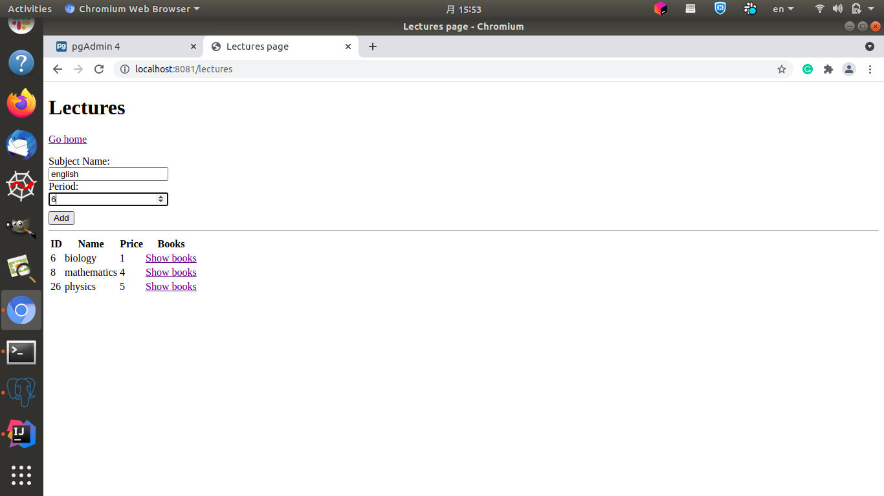

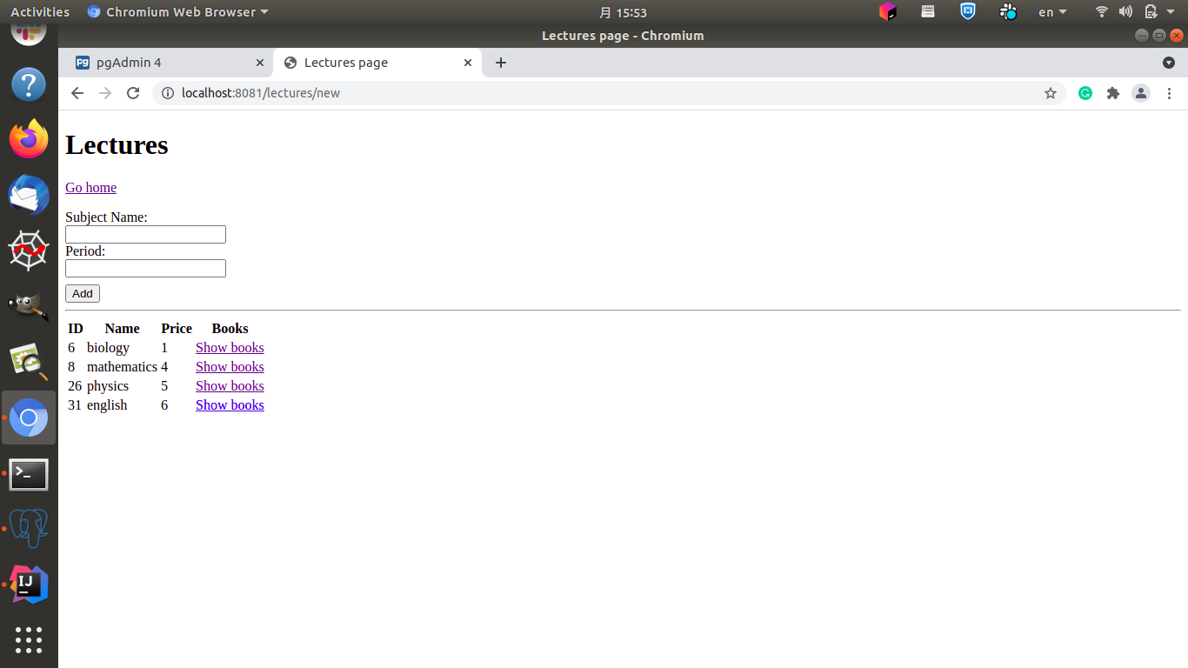

**Spring Security,**

Spring Security is a framework that focuses on providing both authentication and authorization to Java applications. Like all Spring projects, the real power of Spring Security is found in how easily it can be extended to meet custom requirements

**Files Necessary for the setting security,**

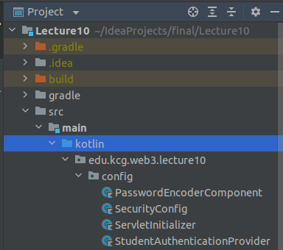

**The output of these will result in this.**

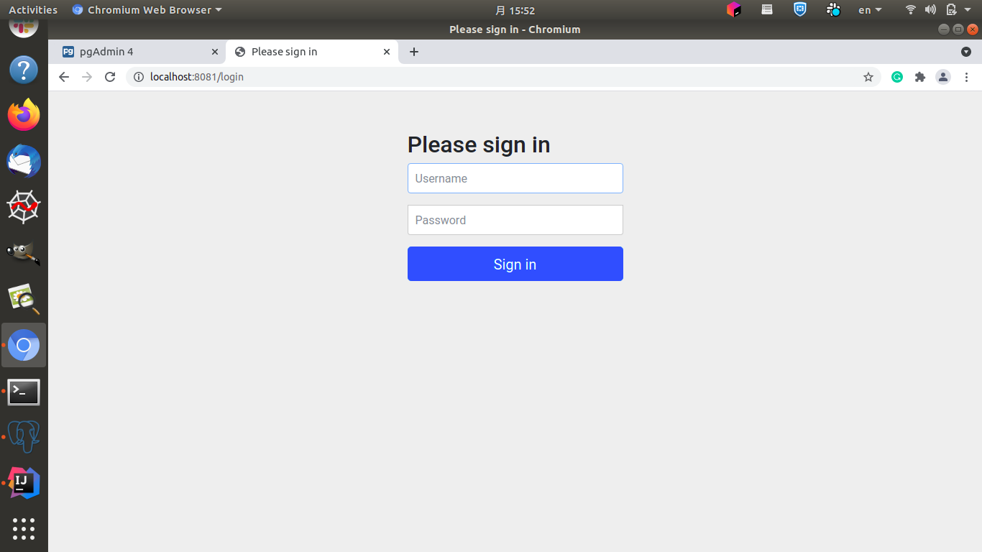

**Rest Controller**

A REST API (also known as RESTful API) is an application programming interface (API or web API) that conforms to the constraints of REST architectural style and allows for interaction with RESTful web services. REST stands for representational state transfer and was created by computer scientist Roy Fielding.

So the implementation is done by this file.

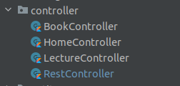

Code will look like this in it.

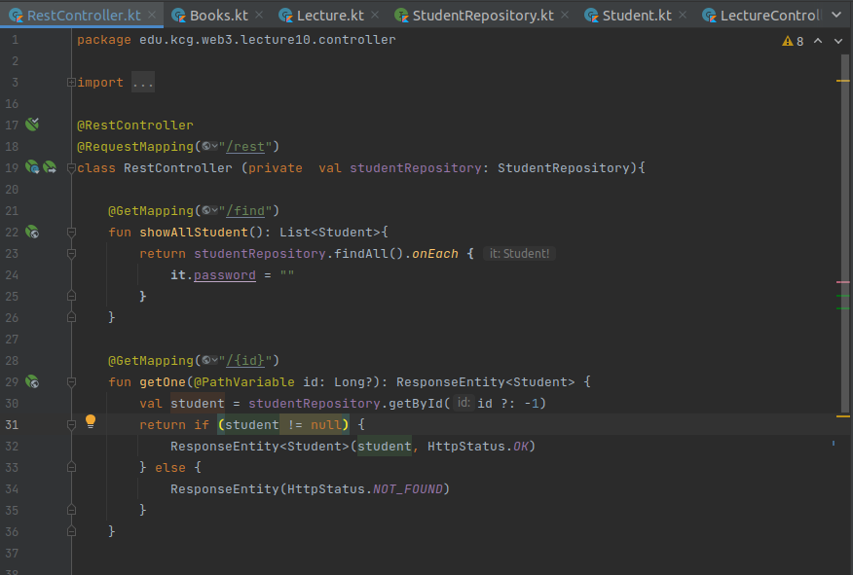

Now the output is like this.

